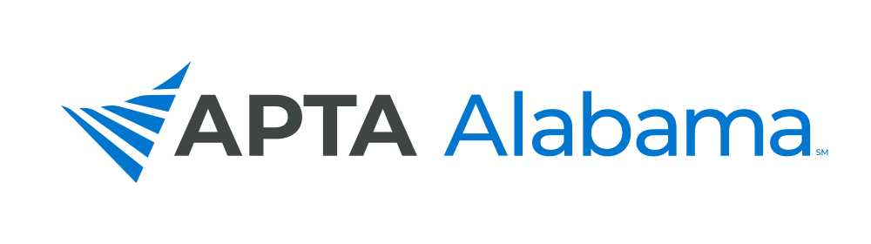

2022 NOMINATION & INTEREST FORM

The following positions will be elected in 2022. Please indicate which position you are submitting a nomination for.

- President (1 position for a 2-year term)
- PT Representative-at-Large (1 position for a 2-year term)
- PTA Representative-at-Large (1 position for a 2-year term)
- Delegate (1 position for a 2-year term)
- Nominating Committee (1 position for a 3-year term)

Member Being Nominated: _______________________________________________________________________

Please identify the qualities that you believe this member exemplifies:

_____ Accountable/Responsible
_____ Articulate
_____ Collaborative
_____ Creative
_____ Decisive
_____ Dependable
_____ Detail-oriented
_____ Empowering
_____ Knowledgeable in Parliamentary procedures

_____ Organized
_____ Persuasive
_____ Risk taker
_____ Skilled Communicator
_____ Skilled Leader
_____ Skilled Mentor
_____ Skilled Negotiator
_____ Visionary
_____ Timely in Responsiveness to Emails

Other talents and abilities this member displays, that would make him/her a good candidate:

_________________________________________________________________________________________________

_________________________________________________________________________________________________

COMMITTEE INTEREST

Please check below which Committee you may be interested in serving on.

_____ Bylaws _____ Diversity, Equity & Inclusion (DEI) _____ Education
_____ Ethics _____ Federal Government Affairs _____ Finance
_____ Government Affairs _____ Membership _____ PAC
_____ Practice & Payment _____ Publicity & Communications

Send To: info@ptalabama.org

NOMINATION DEADLINE – JUNE 15, 2022

