
AWARDS

Marilyn Gossman Professionalism in Physical Therapy Award

Purpose: To honor an APTA Alabama member demonstrating outstanding professionalism in any of the areas of physical therapy service, practice, education and/or research.

Eligibility:

- APTA Alabama Member
- Engaged in the physical therapy profession for at least fifteen (15) years.
- Has positively and substantially affected the shape, scope, and quality of physical therapy practice in Alabama.
- Has had an impact on other physical therapy professionals in a manner that has significantly increased their abilities to practice physical therapy.

Governmental Affairs Award

Purpose: To recognize an APTA Alabama Member most effective in positively representing the physical therapy profession through political activities influencing state or national legislation.

Eligibility:

- APTA Alabama Member
- Has worked with the Governmental Affairs Committee and/or APTA Alabama lobbyist.
- Has participated in political activities that have directly influenced state and/or national legislation.

Barbara Bradford Leadership Award

Purpose: To recognize an APTA Alabama Member who has made significant contributions resulting in Chapter growth as well as individuals who have demonstrated outstanding leadership in their service to APTA Alabama.

Eligibility:

- APTA Alabama Member
- Has been involved as a Chapter leader for a minimum of two (2) years.

Physical Therapy Advocate Award

Purpose: To recognize an individual outside of the profession whose activities promote and elevate the practice of physical therapy.

Eligibility:

- Not a licensed PT or PTA
- Has participated in activities that facilitate the delivery of effective physical therapy services and/or enhance public awareness of physical therapy.

Innovations in Physical Therapy Award

Purpose: To honor a physical therapy professional or clinic demonstrating futuristic thinking through innovative programming.

Eligibility:

- APTA Alabama Member. Clinics nominated must employ at least one APTA Alabama Member.
- Demonstrate that activities have represented creative and effective solutions to problems interfering with the optimal delivery of physical therapy services.
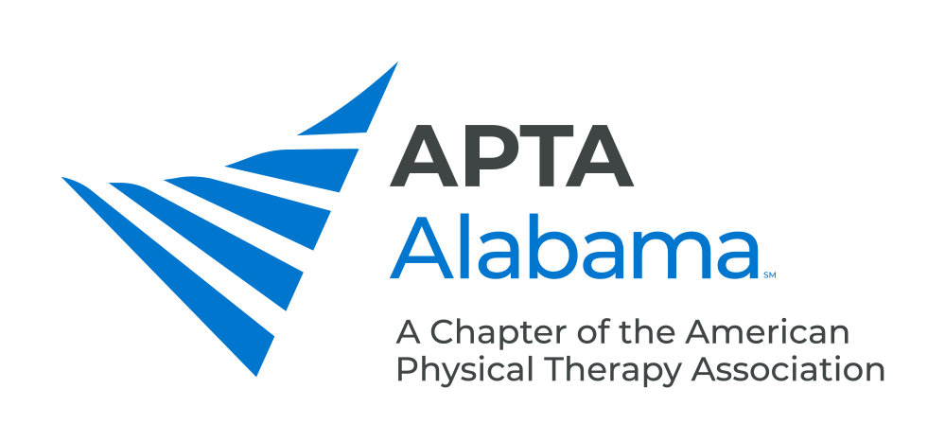
AWARDS NOMINATION FORM

INDIVIDUAL NOMINATED | AWARD NOMINATED FOR

NOMINATOR

Name: ______________________________________________________________________

E-mail Address: ______________________________________________________________________

Please send the Nomination Form and Letter(s) of Support to:

info@ptalabama.org by July 1

